How to Enable Barnes & Noble First Day Complete Course Materials
Inside Your Blackboard Course

- Log into Blackboard at http://blackboard.njcu.edu with your GothicNet credentials.

- Select your Fall 2022 course shell from your course list. If you do not see your Fall 2022 Blackboard course shell, try navigating to the Fall 2022 term by clicking the triangle to the right of “Current Courses” (see below). If you still do not see your Fall 2022 Blackboard course shell, confirm with your Department chair that you are assigned to your course in GothicNet.

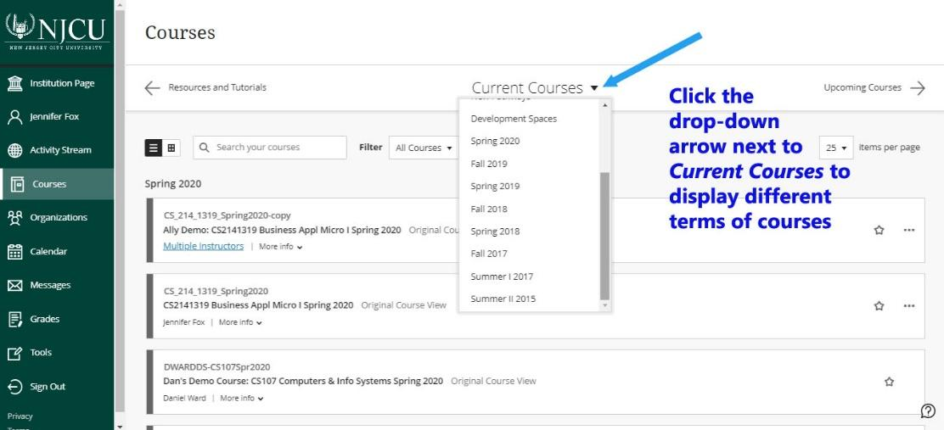

- Enable the First Day Course Materials Tool link.

- If using the Blackboard Original course view:
- Click the chevron to the right of the First Day Course Materials tool link in the left course menu inside your Blackboard course
- Select Show Link

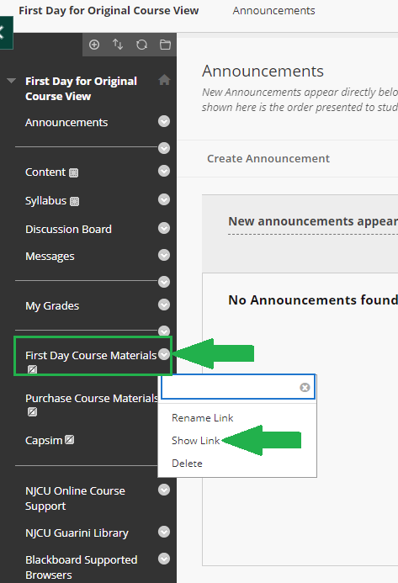

- If using the Blackboard Ultra course view:
- Select the “View course & institution tools” link from the Details & Actions area of your Blackboard course

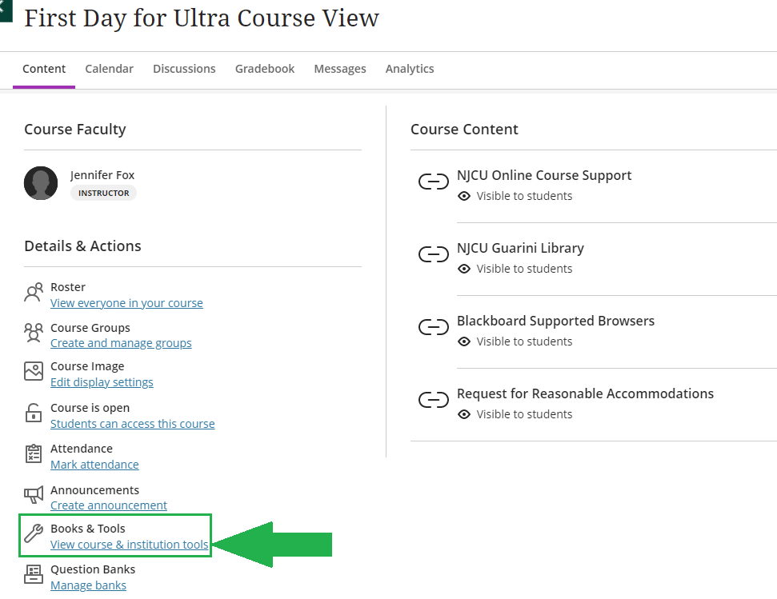

- Select the plus sign to the left of the First Day Course Materials tool to add it to your Course Content area

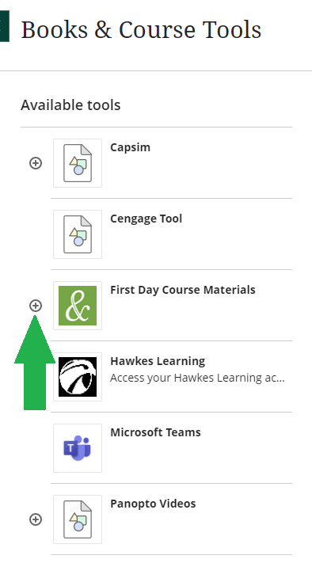

- Show the link by clicking “Hidden from Students” and selecting “Visible to Students”

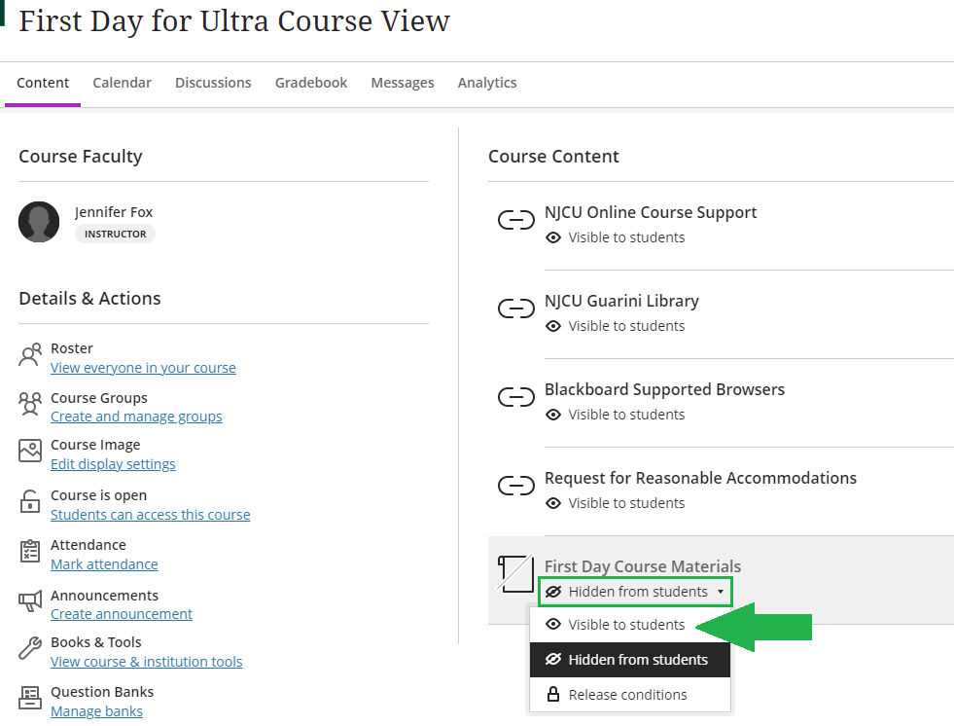

If you need assistance enabling the tool in Blackboard, you should email helpdesk@njcu.edu to generate a helpdesk ticket for the Department of Online Learning or fill out the Blackboard Support Request Form.

